1. Create HTML for form.png (check resources, highest weightage for answers)
bug.html
form1.html
<!doctype html>
<html>
<head>
<meta charset="utf-8">
<meta name="viewport" content="width=device-width, initial-scale=1.0">

<link rel="stylesheet" href="https://stackpath.bootstrapcdn.com/bootstrap/4.4.1/css/bootstrap.min.css" integrity="sha384-Vkoo8x4CGsO3+Hhxv8T/Q5PaXtkKtu6ug5TOeNV6gBiFeWPGFN9MuhOf23Q9Ifjh" crossorigin="anonymous">
<link rel="stylesheet" type="text/css" href="form.css">
<title>Bug report</title>
</head>
<body>
<div id="container-fluid">
<div class="container-fluid">
<span style="float:left;font-size: 20px;font-weight:bold ;color: #10D5D2;">TO THE NEW</span>
<span style="float:right;"><a href="#">Home</a> <a href="#">Quick Help</a></span>
</div>
<br />
<hr />
<br />
<div class="container bug-box">
<div style="background-color: #696969;width: 290px;padding:5px;">
<h3>Bug report</h3>
</div>
<form action="#" method="post">
Title:*<br />
<input type="text" name="title" required><br /><br>
Description:*<br />
<textarea name="description" required></textarea><br /><br>
Operating system:<br />
<select name="os" style="background-color: mediumseagreen;">
<option value="xp">Windows XP</option>
<option value="7">Windows 7</option>
</select><br /><br>
Product:*<br />
<select name="product" style="background-color: mediumseagreen;">
<option value="id">Product ID</option>
<option value="sno">Serial No</option>
</select><br /><br>
Version:*<br />
<input type="text" name="version"><br /><br>
License:<br />
<input type="radio" name="license" value="free"> Free
<input type="radio" name="license" value="business"> Business<br/><br>
Severity:<br />
<select name="Severity" style="background-color: mediumseagreen;">
<option value="critical">Critical</option>
<option value="serious">Serious</option>
</select><br /><br>
Attachment:<br />
<input type="file" name="file">
<p align ="right" ><input[type=text], select, textarea{
width:280px;
}
.bug-box{
width:300px;
margin:0 auto;
border:2px solid black;
padding: 5px;
border-radius: 10px;
}
a {
text-decoration: none;
color: #10D5D2;
}
.btn{
float:right;
}
/p>
<div class="btn"><input type="submit" value="Send" style="background-color: mediumseagreen;"></div>
</p>

</form>

</div>
</div>
</body>
</html>

form.css
input[type=text], select, textarea{
width:280px;
}
.bug-box{
width:300px;
margin:0 auto;
border:2px solid black;
padding: 5px;
border-radius: 10px;
}
a {
text-decoration: none;
color: #10D5D2;
}
.btn{
float:right;
}

OUTPUT
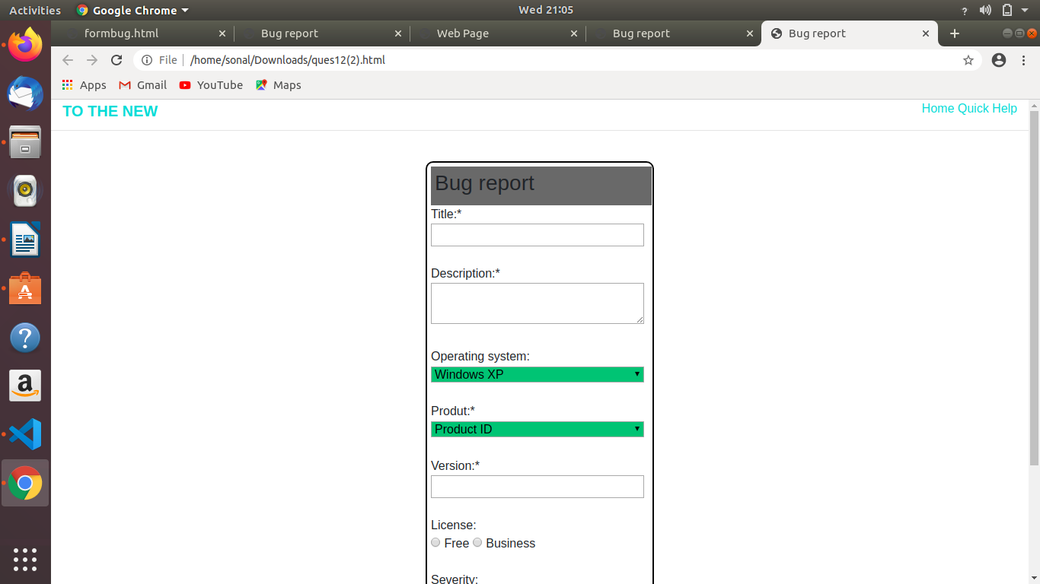

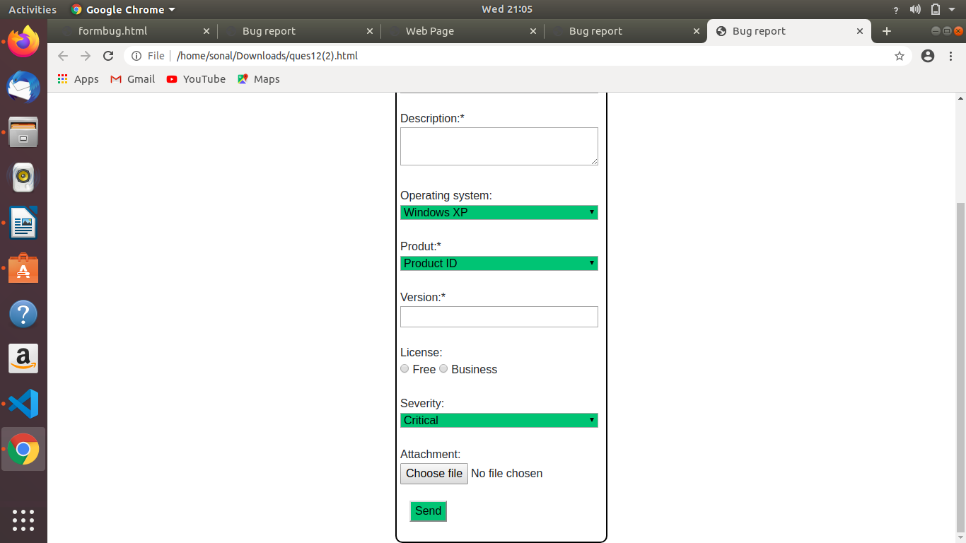

11. Create HTML for web-page.jpg (check resources, highest weightage for answers)
tst.html

son.html

<html>
<title>First page</title>
<head>
<link rel="stylesheet" href="https://stackpath.bootstrapcdn.com/bootstrap/4.4.1/css/bootstrap.min.css" integrity="sha384-Vkoo8x4CGsO3+Hhxv8T/Q5PaXtkKtu6ug5TOeNV6gBiFeWPGFN9MuhOf23Q9Ifjh" crossorigin="anonymous">
<style type="text/css">
h1{
color: white;
}
</style>
</head>
<body>
<div style="padding-left: 5%; padding-right: 5%; background: #424242;">
<header style="background: #2D2E2E; height: 20%">
<div class="container-fluid">
<h1>To the New</h1>
<br>
<nav class="navbar navbar-expand-sm" style="background: #1C1C1C;">
<ul class="navbar-nav" style="color: white;">
<li class="nav-item pr-4" >TEXT LINK</li>
<li class="nav-item pr-4">TEXT LINK</li>
<li class="nav-item pr-4">TEXT LINK</li>
<li class="nav-item pr-4">TEXT LINK</li>
<li class="nav-item pr-4">TEXT LINK</li>
</ul>
</nav>
</div>
</header>
<div style="background: white; padding-right: 50px; padding-left: 50px">
<svg class="bd-placeholder-img card-img-top mt-5 mb-5" width="100%" height="280">
<rect width="100%" height="100%" fill="#1C1C1C"/>
<text x="45%" y="50%" fill="#dee2e6">960x360px</text>
</svg>
<div class="jumbotron pt-1 pb-1 pr-2 pl-2">
Harold the family dog narrates three stories of life with supernatural suspicions which begins with Bunnicula, the bunny with fangs. Inn while boarding at the Chateau Bow-Wow, Harold and Chester (the Monroe cat) encounter a werewolf, perhaps. Chester and Harold must stop zombie vegetables when the Celery Stalks at Midnight.
</div>
<h2>LATEST FROM GALLERY</h2>
<hr>
<div class="row">
<ul class="list-inline" style="margin-left: 1%; padding:3px;">
<li class="list-inline-item border border-secondary pl-1 pr-1">
<div class="img"><img src="https://via.placeholder.com/215x315
C/O https://placeholder.com/" class="rounded" alt="..."></div><p></p>
<p class="jumbotron pt-1 pb-1 pr-2 pl-2"> IMAGE CAPTION HERE</p>
</li>
<li class="list-inline-item border border-secondary pl-1 pr-1" style="margin:0 0 0 40px">
<div class="img"><img src="https://via.placeholder.com/215x315
C/O https://placeholder.com/" class="rounded" alt="..."></div><p></p>
<p class="jumbotron pt-1 pb-1 pr-2 pl-2"> IMAGE CAPTION HERE</p>
</li>

<li class="list-inline-item border border-secondary pl-1 pr-1 " style="margin:0 0 0 40px">
<div class="img"><img src="https://via.placeholder.com/215x315
C/O https://placeholder.com/" class="rounded" alt="..."></div><p></p>
<p class="jumbotron pt-1 pb-1 pr-2 pl-2"> IMAGE CAPTION HERE</p>
</li>

<li class="list-inline-item border border-secondary pl-1 pr-1 " style="margin:0 0 0 40px">
<div class="img"><img src="https://via.placeholder.com/215x315
C/O https://placeholder.com/" class="rounded" alt="..."></div><p></p>
<p class="jumbotron pt-1 pb-1 pr-2 pl-2"> IMAGE CAPTION HERE</p>
</li>
</ul>
</div>
<div class="text-center">
</div>
</div>
<footer class="page-footer font-small pt-4 " style="background: black;">
<div class="container-fluid text-center text-md-left">
<div class="row">
<div class="col-md-9 mt-md-0 mt-3">
<p style="color: white;">Copyright © 2009 - 2017 - All Rights reserved To the new</p>
</div>
<div class="col-md-3">
<p style="color: white;">Web layout by To the new</p>
</div>
</div>
</footer>
</div>
</body>
</html>

